CSAA Bootcamp – June 2019

Problem Scenario #3

Table of Contents

1 Document Definition 2

2 Problem Statement 2

3 Solution 2

3.1 Key Considerations 2

3.2 Technology Assumptions 2

3.3 AWS Services 3

3.4 Architecture Design 3

3.4.1 Solution 1 3

3.4.2 Solution 2 4

# Document Definition

The purpose of this document is to present a solution to the Problem Scenario #3.

# Problem Statement

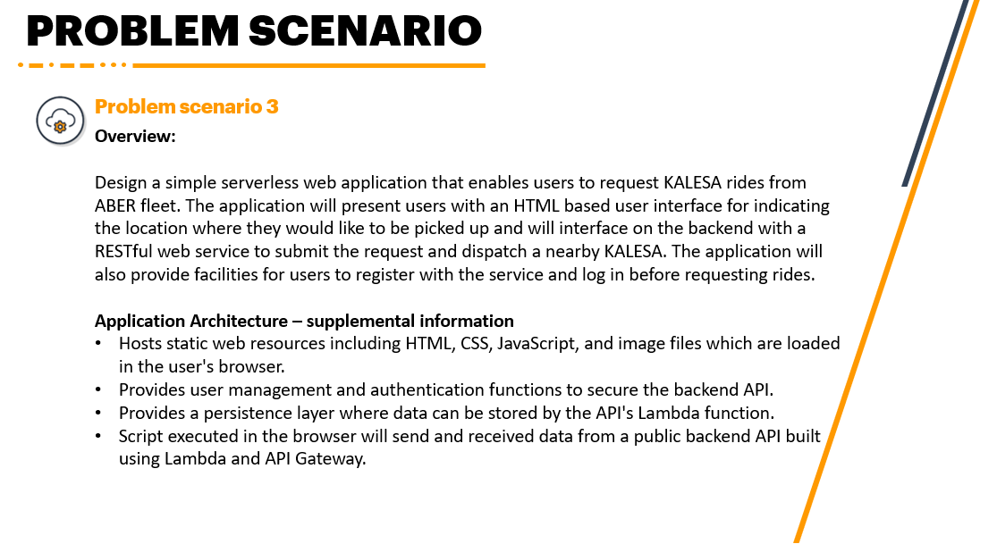

# Solution

## Key Considerations

The following are the key considerations for this solution:

1. Serverless web application
2. HTML-based user interface
3. With location API
4. Restful Web Services
5. With user management and authentication
6. With persistence layer

## Technology Assumptions

The following are the technology assumptions for this solution:

1. Operational expense is not constrained.
2. User-friendly FQDN is required.
3. The application is a Progressive Web Application.

## AWS Services

To achieve the considerations defined, the following AWS Services will be required:

## Architecture Design

Below is the architecture designed to achieve the key considerations:

